A PROJECT REPORT ON

ON

Hospital Readmission Prediction Using Elastic Net Regularized Logistic Regression

project report submitted in partial fulfilment of the requirements for the Course

MACHINE LEARNING

BACHELOR OF TECHNOLOGY

In

A.Y.: 2026-27

By

2500031613 — Uppalapati Moksha Ratna
252003004 — Sinde Vedhanth
2520030025 — Vootla Hemanth

Under the Esteemed guidance of

GADDAM RAVINDRA BABU

Project Guide

Department of Computer Science and Engineering

Abstract
Hospital readmission is an important healthcare outcome because patients who return to the hospital soon after discharge may require additional clinical attention and follow-up. This project presents the design and implementation of a machine learning based clinical decision-support demonstration system for predicting 30-day hospital readmission using Elastic Net regularized Logistic Regression. The project uses the Diabetes 130-US Hospitals dataset, containing 101,766 hospital encounters. The cleaned project dataset has 43 columns, with the target defined as <30 days = 1 and >30 days or NO = 0. Data preprocessing includes missing-value handling, removal of identifiers and unsuitable high-missingness fields, categorical encoding, numerical standardization and feature selection. A compact patient-facing Elastic Net model uses age group, gender, admission type, time in hospital, number of diagnoses, number of medications, number of procedures, previous visits, previous emergency visits, previous outpatient visits, diabetes medication and insulin. The trained model achieved 67.78% accuracy, 17.16% precision, 49.32% recall, 25.46% F1-score and 64.25% ROC-AUC on the held-out test set. The model is integrated into a React and FastAPI application with SQLite storage, patient authentication, automatic retrieval of visit history, prediction records and an administrator dashboard. Blood group and symptom information are collected as patient-assessment information but are not used by the current ML model because those variables are not present in the training dataset. The system is intended as an academic demonstration and not as a clinically validated diagnostic or treatment tool.
Keywords: Hospital Readmission, Elastic Net, Logistic Regression, Machine Learning, Clinical Decision Support, Healthcare Analytics

1. Introduction

1.1 Purpose of the Project
Hospital readmission prediction is a useful machine learning application because hospital records contain information about demographics, admission characteristics, previous healthcare utilization, diagnoses, medications and length of stay. A system that estimates readmission risk can support the identification of patients who may require closer follow-up or additional review. Recent research has explored both conventional statistical models and more complex machine learning methods for this purpose, while also emphasizing the importance of interpretability and clinically meaningful predictors.
The purpose of this project is to develop an end-to-end academic demonstration rather than only a standalone prediction notebook. The system combines a supervised classification model with a patient portal, administrator portal, authentication, SQLite visit storage and automatic retrieval of previous visit history. This demonstrates how a trained model can be integrated into a practical software workflow while keeping the prediction component interpretable.

1.2 Problem Statement
The problem is formulated as a binary classification task: given selected patient and hospital-visit characteristics, predict whether the patient belongs to the project's 30-day readmission class. In the cleaned dataset, encounters with readmission status <30 are encoded as target 1, while >30 and NO are encoded as target 0. The expected output of the application is a probability of readmission together with a demonstration risk category based on the probability returned by the model.

1.3 Existing Methods and Disadvantages
Traditional readmission prediction approaches commonly use logistic regression or manually designed scoring systems. Logistic regression is attractive because it is computationally efficient and produces coefficients that can be inspected. However, hospital datasets can contain many correlated variables and categorical indicators, which can make an unregularized model unstable or difficult to interpret. Simple rule-based systems may also fail to capture relationships between multiple patient and utilization variables.
More complex approaches such as random forests, gradient boosting and deep learning can model nonlinear relationships and interactions, and recent studies have reported strong discrimination for specialized patient groups. However, increased complexity can reduce transparency and make clinical interpretation more difficult. Recent literature therefore includes work on explainable machine learning, local interpretability and longitudinal representations, reinforcing the value of balancing predictive performance with interpretability.

1.4 Proposed System
The proposed system uses a cleaned version of the Diabetes 130-US Hospitals dataset and trains an Elastic Net regularized Logistic Regression classifier. The preprocessing stage converts missing markers to missing values, removes identifiers and fields with unsuitable missingness or variation, imputes remaining values, encodes categorical variables and standardizes numeric variables. The compact model is exposed through a FastAPI backend and connected to a React frontend. SQLite stores users, patient profiles and visit records, allowing previous hospital utilization to be retrieved automatically for later assessments. The application also records blood group and symptoms for the visit, while keeping them separate from the current ML feature set because they are not represented in the training data.

1.5 Research Objectives
- Prepare and validate a suitable hospital readmission dataset for supervised learning.
- Perform systematic data cleaning, missing-value treatment, encoding and numerical standardization.
- Select a compact set of patient-facing features while avoiding target leakage and preserving the meaning of the original variables.
- Develop and train an Elastic Net regularized Logistic Regression model for binary readmission classification.
- Evaluate the model using accuracy, precision, recall, F1-score, ROC-AUC and a confusion matrix.
- Integrate the trained model with a full-stack demonstration application using React, FastAPI and SQLite.
- Maintain patient visit history so that previous utilization can be automatically incorporated into subsequent assessments.
- Discuss limitations, interpretability, data imbalance and the requirements for future clinical validation.

2. Literature Survey (Recent Studies)
Recent literature shows that hospital readmission prediction is being studied across heart failure, diabetes, orthopaedics, sepsis, cardiovascular disease and general hospital populations. The reviewed studies demonstrate recurring themes: the importance of previous utilization and clinical history, the use of logistic regression and tree-based models as baselines, the growing use of explainability methods, and the potential value of longitudinal or wearable data. Ten recent studies are summarized below.

S.No. | Title | Reference with DOI | Problem / gap | Objective | Methods | Inference | Future research
1 | Interpretable machine learning models for hospital readmission prediction: a two-step extracted regression tree approach | Gao et al. (2023), BMC Med Inform Decis Mak, 23, 104. DOI 10.1186/s12911-023-02193-5 | Black-box models can be difficult to interpret. | Retain predictive performance while exposing meaningful risk factors. | Black-box ML + extracted regression tree. | Comparable predictive performance with greater interpretability. | External validation and clinical evaluation.
2 | The Price of Explainability in Machine Learning Models for 100-Day Readmission Prediction in Heart Failure | Soliman et al. (2023), Journal of Medical Internet Research, 25. DOI 10.2196/46934 | Complex models may trade interpretability for performance. | Assess predictive-performance/explainability trade-offs. | Comparative ML study of classification models. | Highlights the practical cost and value of explainability. | Develop accurate and interpretable models.
3 | Predicting 30-day readmission following total knee arthroplasty using machine learning and clinical expertise... | Gould et al. (2023), Arthroplasty, 5, 30. DOI 10.1186/s42836-023-00186-3 | Procedure-specific readmission risk is multifactorial. | Predict 30-day readmission using clinical and administrative data. | ML with registry and administrative data plus clinical expertise. | Shows value of combining clinical knowledge with ML. | External and prospective validation.
4 | Predicting the risk of hospital readmissions using a machine learning approach: a case study on patients undergoing skin procedures | Adhiya et al. (2024), Front Artif Intell, 6, 1213378. DOI 10.3389/frai.2023.1213378 | Different algorithms identify different predictors. | Compare models and identify important readmission factors. | LR, SVM, RF, NB, ANN, XGBoost and KNN. | XGBoost and RF performed strongly in the cohort. | Test generalization beyond skin procedures.
5 | Machine learning-based 30-day readmission prediction models for patients with heart failure: a systematic review | Yu & Son (2024), Eur J Cardiovasc Nurs, 23(7), 711–719. DOI 10.1093/eurjcn/zvae031 | Evidence quality and predictors vary across studies. | Review ML models and significant predictors. | Systematic review of 13 studies. | Identifies recurring predictors and reporting issues. | Improve validation and reporting standards.
6 | Explainable machine learning for predicting 30-day readmission in acute heart failure patients | Zhang et al. (2024), iScience, 27(7), 110281. DOI 10.1016/j.isci.2024.110281 | Traditional LR may underperform flexible ML models. | Develop and explain an AHF readmission model. | Five ML algorithms, 5-fold CV and SHAP. | XGBoost achieved the best AUC in the study. | External validation and calibration.
7 | Global and Local Interpretable Machine Learning Allow Early Prediction of Unscheduled Hospital Readmission | Ruiz de San Martín et al. (2024), ML Knowledge Extraction, 6(3), 1653–1666. DOI 10.3390/make6030080 | Repeated readmissions motivate individualized prediction. | Develop local models for early identification. | Multiple ML models + local model-agnostic explanations. | Local explanations support individualized risk analysis. | Prospective and external evaluation.
8 | Application of machine learning algorithms to predict 30-day hospital readmission following cement augmentation... | Cabrera et al. (2024), World Neurosurg X, 23, 100338. DOI 10.1016/j.wnsx.2024.100338 | Surgical readmission risk needs quantification. | Predict readmission after cement augmentation. | Three ML algorithms on ACS-NSQIP data. | Mean AUC 0.757; age and postoperative factors were important. | Prospective and broader-cohort validation.
9 | Impact of wearable device data and multi-scale entropy analysis on improving hospital readmission prediction | Nagarajan et al. (2024), JAMIA, 31(11), 2679–2688. DOI 10.1093/jamia/ocae242 | Static data may miss post-discharge changes. | Test whether wearable data improve prediction. | FNN and LSTM with clinical and wearable features. | LSTM AUC exceeded FNN in the study cohort. | Prospective validation and accessibility assessment.
10 | Survival models and longitudinal medical events for hospital readmission forecasting | Davis & Greiner (2024), BMC Health Serv Res, 24, 1394. DOI 10.1186/s12913-024-11771-w | Binary labels ignore time to readmission. | Explore survival-style longitudinal forecasting. | Survival-inspired model + longitudinal representations. | Shows value of time-to-event and longitudinal history. | Evaluate across diseases and horizons.

3. Methodology

3.1 Proposed System Flow Diagram
Dataset | Data Cleaning | Missing Values | Encoding & Scaling | Feature Selection
Train/Test Split | Elastic Net Training | Prediction | Evaluation | Web Application
The proposed workflow begins with the cleaned UCI dataset and proceeds through missing-value treatment, categorical encoding, numerical scaling, compact feature selection and an 80/20 train-test split. The Elastic Net Logistic Regression model is trained on the training data and evaluated on held-out data. The final model is stored as a portable artifact and called by the FastAPI backend. The React frontend collects current-visit information and displays the resulting probability and risk category.

3.2 Dataset Description
The project uses the Diabetes 130-US Hospitals dataset sourced from the UCI Machine Learning Repository. The original dataset contains 101,766 hospital encounters and 50 CSV columns. The project cleaning workbook contains 101,766 rows and 43 cleaned columns. The target is readmitted, encoded as <30 = 1 and >30/NO = 0. The cleaned target distribution is 90,409 negative encounters (88.84%) and 11,357 positive encounters (11.16%).
Dataset property | Value
Source | UCI Machine Learning Repository — Diabetes 130-US Hospitals
Original records | 101,766
Original CSV columns | 50
Cleaned records | 101,766
Cleaned columns | 43
Target | readmitted
Target encoding | <30 = 1; >30/NO = 0
Negative class | 90,409 (88.84%)
Positive class | 11,357 (11.16%)
Missing cells before cleaning | 374,017
Missing cells after cleaning | 0
Duplicate rows before cleaning | 0

3.3 Experimental Setup
The machine learning environment uses Python 3.10.5 with Pandas, NumPy, scikit-learn, Matplotlib and Seaborn. The application uses FastAPI for the backend, React with Vite for the frontend and SQLite for persistent application data. Development and local testing were performed on a Windows-based system. The FastAPI service runs locally on port 8000 and the React development server on port 5173.

3.4 Data Preprocessing
- Question-mark missing markers were converted to missing values for consistent analysis.
- Unique encounter and patient identifiers were excluded from the core model.
- Fields with very high missingness, including weight, payer_code and medical_specialty, were removed from the core experiment.
- Fields with no useful variation were removed to simplify the feature space.
- Categorical missing values were handled with an Unknown category and numeric missing values with median imputation.
- Categorical variables were one-hot encoded and numeric variables were standardized.
- The target was converted to a binary 30-day readmission label.
- A stratified 80/20 train-test split and balanced class weighting were used for the compact model.

3.5 Exploratory Data Analysis
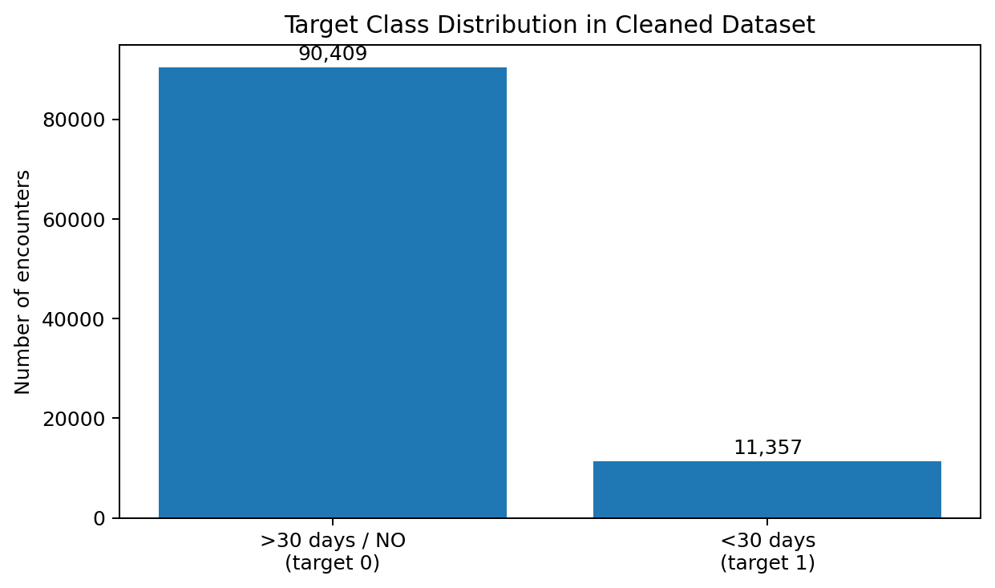
Figure 1. Target class distribution in the cleaned dataset.
The positive class represents only 11.16% of encounters, so class imbalance is a central consideration in model evaluation. This is why the project reports recall, precision, F1-score and ROC-AUC in addition to accuracy.

3.6 Feature Engineering and Feature Selection
The patient-facing model was reduced to 12 features: age_group, gender, admission_type, time_in_hospital, num_diagnoses, num_medications, num_procedures, previous_visits, previous_emergency_visits, previous_outpatient_visits, diabetes_medication and insulin. This reduction keeps the interface understandable while using variables available in the training data. The application maps the patient-facing Casual Check-up admission option to the model's Other category. Blood group and symptom fields are collected and stored but are not used by the current model because the training dataset does not contain those variables.

3.7 Model Building and Training
The proposed classifier is Logistic Regression with an Elastic Net penalty. Logistic Regression estimates the positive-class probability through a sigmoid transformation of a linear score. Elastic Net combines L1 and L2 penalties. The current model artifact records C = 0.05, l1_ratio = 0.20, penalty = elasticnet, solver = SAGA and class_weight = balanced. The saved artifact stores category maps, numeric scaling parameters, coefficients and intercept, making inference less dependent on the installed scikit-learn serialization interface.

3.8 Hyperparameter Tuning
The final compact configuration recorded in the model artifact uses C = 0.05 and l1_ratio = 0.20. The report does not claim an unrecorded exhaustive search; these values are presented as the selected configuration for the current project artifact. Balanced class weights were used to reduce the influence of the 11.16% positive-class prevalence.

3.9 Model Evaluation
Evaluation uses accuracy, precision, recall, F1-score and ROC-AUC, together with a confusion matrix. Accuracy summarizes overall correctness; precision measures the fraction of predicted positives that are actually positive; recall measures the fraction of actual positives detected; F1 balances precision and recall; and ROC-AUC summarizes discrimination across probability thresholds.

4. Results and Discussion

4.1 Preprocessing Results
Metric | Before | After
Rows | 101,766 | 101,766
Columns | 50 | 43
Missing cells | 374,017 | 0
Duplicate rows | 0 | 0
Target encoding | <30, >30, NO | <30 → 1; >30/NO → 0

The cleaning process preserved all 101,766 encounters while reducing the number of columns from 50 to 43 and reducing missing cells from 374,017 to zero. The workbook records no duplicate rows before cleaning.

4.2 Model Performance
Model | Accuracy | Precision | Recall | F1-score | ROC-AUC
Compact Elastic Net Logistic Regression | 67.78% | 17.16% | 49.32% | 25.46% | 64.25%

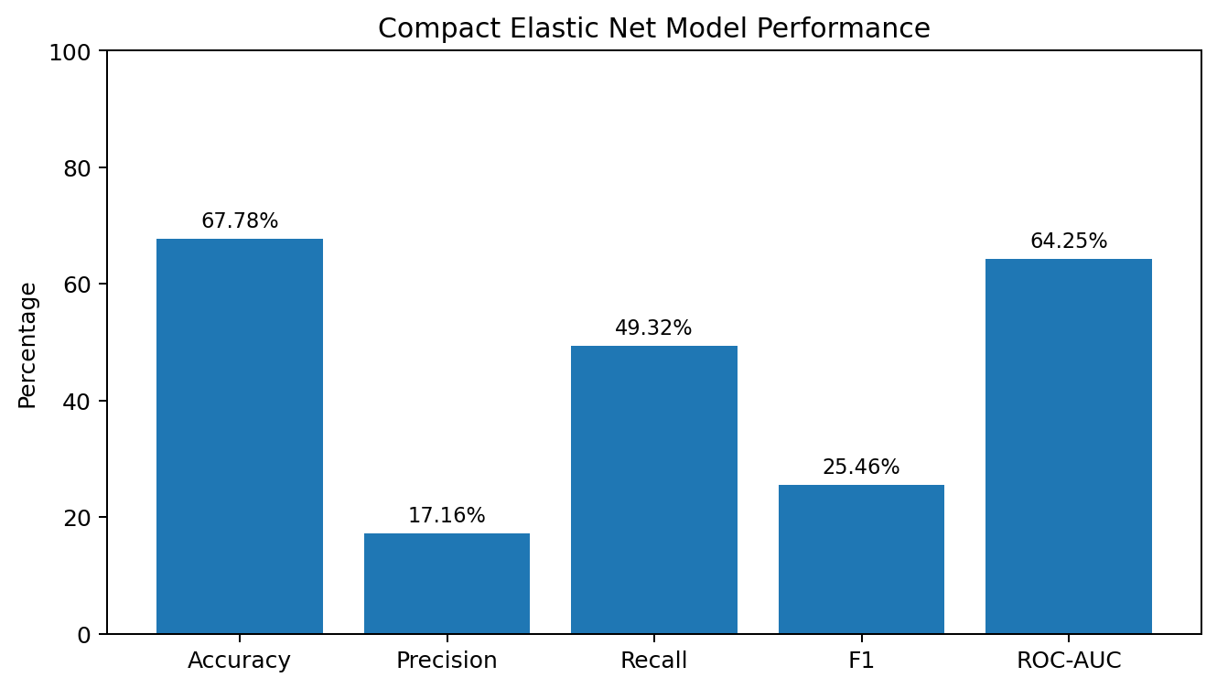
Figure 2. Compact Elastic Net model performance.
The model obtains 67.78% accuracy and 64.25% ROC-AUC. Recall is 49.32%, while precision is 17.16%, reflecting the difficulty of identifying a relatively rare positive class. The F1-score is 25.46%. These values describe the academic demonstration model and should not be interpreted as clinical readiness.

4.3 Visual Results and Discussion
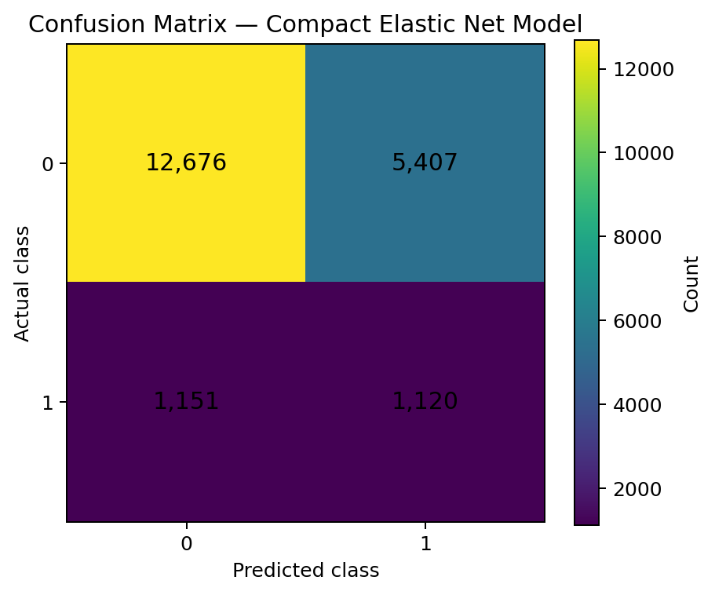
Figure 3. Confusion matrix of the compact Elastic Net model.
Actual \ Predicted | 0 | 1
0 | 12,676 | 5,407
1 | 1,151 | 1,120

The confusion matrix contains 12,676 true negatives, 5,407 false positives, 1,151 false negatives and 1,120 true positives. The relatively large number of false positives explains the low precision, while the 1,120 true positives demonstrate that the model identifies a meaningful portion of the positive cases at the selected threshold. The class imbalance and balanced weighting make it necessary to consider several metrics rather than accuracy alone.
The application layer adds a second contribution beyond the classifier. Patient profile information is loaded after login, previous hospital, emergency and outpatient visit counts are retrieved from SQLite, and completed assessments are stored as visit records. This allows repeated demonstrations of a patient's accumulated history. Blood group and symptoms are recorded separately because they are not represented in the training data used by the current model.

5. Conclusion
This project developed an end-to-end hospital readmission prediction demonstration using Elastic Net regularized Logistic Regression. It combines a cleaned hospital dataset, systematic preprocessing, a compact 12-feature classifier, a React patient interface, FastAPI services, SQLite storage and an administrator portal. The model achieved 67.78% accuracy and 64.25% ROC-AUC on the held-out test set, with the expected precision-recall trade-off under class imbalance.
The main practical contribution is the integration of the model with a persistent patient workflow. Previous visit information is retrieved automatically from the database rather than being manually re-entered, and each completed assessment becomes part of the patient's visit history. The system is suitable for academic demonstration, but external validation, calibration, privacy controls and clinical evaluation would be required before any real-world medical use.

6. Future Work
- Use larger, more diverse and externally validated datasets.
- Compare Elastic Net with additional algorithms and calibrated ensemble methods.
- Perform deeper hyperparameter optimization and probability calibration.
- Investigate explainable AI techniques such as coefficient-based explanations and SHAP where appropriate.
- Add symptom and laboratory variables only when suitable training data are available.
- Represent the timing and sequence of patient visits explicitly using longitudinal or survival approaches.
- Evaluate subgroup performance, robustness, calibration and model drift.
- Develop secure cloud deployment only after privacy, governance and validation requirements are satisfied.
- Add clinician review and feedback rather than treating model output as an autonomous medical decision.

7. References
[1] Gao, X., Alam, S., Shi, P., Dexter, F., & Kong, N. (2023). Interpretable machine learning models for hospital readmission prediction: a two-step extracted regression tree approach. BMC Medical Informatics and Decision Making, 23, 104. https://doi.org/10.1186/s12911-023-02193-5.
[2] Soliman, A., Agvall, B., Etminani, K., Hamed, O., & Lingman, M. (2023). The Price of Explainability in Machine Learning Models for 100-Day Readmission Prediction in Heart Failure: Retrospective, Comparative, Machine Learning Study. Journal of Medical Internet Research, 25. https://doi.org/10.2196/46934.
[3] Gould, D. J., Bailey, J. A., Spelman, T., Bunzli, S., Dowsey, M. M., et al. (2023). Predicting 30-day readmission following total knee arthroplasty using machine learning and clinical expertise applied to clinical administrative and research registry data in an Australian cohort. Arthroplasty, 5, 30. https://doi.org/10.1186/s42836-023-00186-3.
[4] Adhiya, J., Barghi, B., & Azadeh-Fard, N. (2024). Predicting the risk of hospital readmissions using a machine learning approach: a case study on patients undergoing skin procedures. Frontiers in Artificial Intelligence, 6, 1213378. https://doi.org/10.3389/frai.2023.1213378.
[5] Yu, M.-Y., & Son, Y.-J. (2024). Machine learning-based 30-day readmission prediction models for patients with heart failure: a systematic review. European Journal of Cardiovascular Nursing, 23(7), 711–719. https://doi.org/10.1093/eurjcn/zvae031.
[6] Zhang, Y., Xiang, T., Wang, Y., Shu, T., Yin, C., Li, H., Duan, M., Sun, M., Zhao, B., Kadier, K., Xu, Q., Ling, T., Kong, F., & Liu, X. (2024). Explainable machine learning for predicting 30-day readmission in acute heart failure patients. iScience, 27(7), 110281. https://doi.org/10.1016/j.isci.2024.110281.
[7] Ruiz de San Martín, R., Morales-Hernández, C., Barberá, C., Martínez-Cortés, C., Banegas-Luna, A. J., Segura-Méndez, F. J., Pérez-Sánchez, H., Morales-Moreno, I., & Hernández-Morante, J. J. (2024). Global and Local Interpretable Machine Learning Allow Early Prediction of Unscheduled Hospital Readmission. Machine Learning and Knowledge Extraction, 6(3), 1653–1666. https://doi.org/10.3390/make6030080.
[8] Cabrera, A., Bouterse, A., Nelson, M., Thomas, L., Ramos, O., Cheng, W., & Danisa, O. (2024). Application of machine learning algorithms to predict 30-day hospital readmission following cement augmentation for osteoporotic vertebral compression fractures. World Neurosurgery: X, 23, 100338. https://doi.org/10.1016/j.wnsx.2024.100338.
[9] Nagarajan, V., Shashikumar, S. P., Malhotra, A., Nemati, S., & Wardi, G. (2024). Impact of wearable device data and multi-scale entropy analysis on improving hospital readmission prediction. Journal of the American Medical Informatics Association, 31(11), 2679–2688. https://doi.org/10.1093/jamia/ocae242.
[10] Davis, S., & Greiner, R. (2024). Survival models and longitudinal medical events for hospital readmission forecasting. BMC Health Services Research, 24, 1394. https://doi.org/10.1186/s12913-024-11771-w.
[11] Dafrallah, S., & Akhloufi, M. A. (2024). Hospital Re-Admission Prediction Using Named Entity Recognition and Explainable Machine Learning. Diagnostics, 14(19), 2151. https://doi.org/10.3390/diagnostics14192151.
[12] Panchangam, P. V. R., Tejas, A., Thejas, B. U., & Maniaci, M. J. (2024). Machine Learning-Based Prediction of Readmission Risk in Cardiovascular and Cerebrovascular Conditions Using Patient EMR Data. Healthcare, 12(15), 1497. https://doi.org/10.3390/healthcare12151497.

Project Data and Implementation Note
Dataset cleaning statistics in this report are based on the supplied project workbook 'Diabetes_130_US_Hospitals_Actual_Dataset_and_Cleaning(1).xlsx'. Model configuration and evaluation values are based on the current compact Elastic Net model artifact used by the project application. The application is an academic demonstration and should not be used for clinical diagnosis or treatment.

